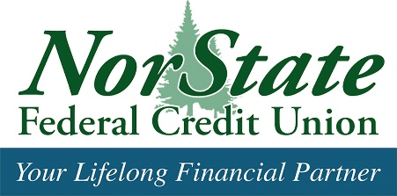

Dear Potential Sponsor,
We are thrilled to announce that NorState Federal Credit Union will be hosting a Bridgerton-themed Queen's Royal Ball on Saturday, October 26, 2024, at 7:00 PM at The North Eastland Hotel in Presque Isle.
This will be our first event of this caliber, and with your support, we aim to make it a resounding success as we strive to reach our goal of $10,000. Alongside the Maine Credit Union League and credit unions across Maine, NorState FCU is deeply committed to ending hunger in our communities. Last year, NorState FCU raised an impressive $36,785.25, contributing to a collective total of over $420,000 since 1999. We recognize the importance of this cause to you and many other local businesses, and with your support, we can significantly impact this critical issue.
We kindly request your generous support for this event. Sponsorships are available at two levels, detailed below:
Platinum - $300
- Recognition of your organization on all our social media platforms
- Special thank you during the event
- One free ticket to the event
Gold - $200
- Recognition the night of the event
We appreciate any donation your organization deems fit. All funds raised from this event will benefit our local food pantries.
To sponsor this event, please make your check payable to NFCU Ending Hunger Campaign and mail it to:
Tina Pelletier, NorState FCU
c/o Queens Royal Ball- A Bridgerton Experience
164 Market St, Fort Kent, ME 04743
Sponsorship deadline is October 20, 2024
Checks can also be dropped off at any of our locations throughout Aroostook County.
Thank you for considering this opportunity to support our mission. Together, we can make a difference in the fight against hunger. Enclosed, please find a copy of our invitation for your viewing pleasure.
Sincerely,
The Ending Hunger Committee
NorState Federal Credit Union

