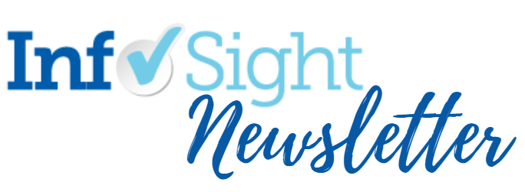

May 28, 2021 | Volume 15 | Issue 21

Highlights
InfoSight by the Numbers

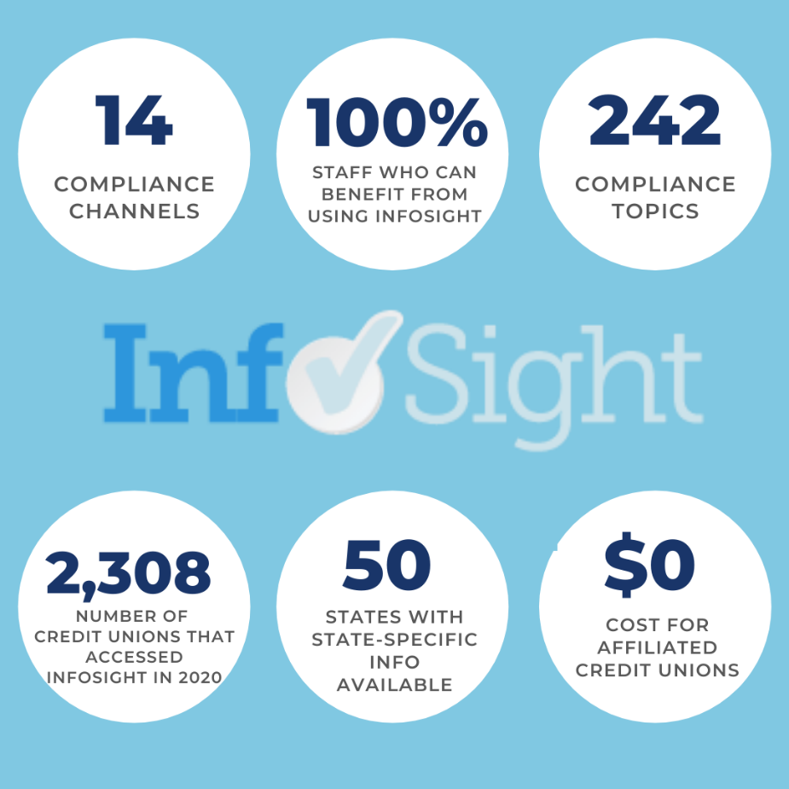

We are very enthusiastic to share these 2020 statistics about InfoSight! With 14 compliance channels that cover 242 compliance topics, it might seem that it’s only for compliance folks. But you can be assured that 100% of your staff and volunteers (e.g., board members!) can benefit from InfoSight and all it offers.

Register Now for CU PolicyPro Training!
We are pleased to offer a series of live training webinars to introduce you to (or reacquaint you with) CU PolicyPro. The training sessions are FREE, but registration is required. Click here to view the session listing and descriptions, and to register for each class. (Please note: there is no session on June 23, and all times are EDT.)

Compliance and Advocacy News & Highlights

Nacha Requests Feedback on Proposals and Posts RFI

Nacha has requested comments and feedback by July 1, 2021, on two related Nacha Rules proposals relating to Third-Party Sender (TPS) Roles and Responsibilities. The proposed rules would become effective June 30, 2022. The purpose of these proposals is to further clarify the roles and responsibilities of TPSs in the ACH network by:
- Addressing the commercially existing practice of Nested TPS arrangements, and
- Making explicit and clarifying the requirement that a TPS conduct a risk assessment
Nacha provided a description of the proposals, and the two proposed rules, and has established a portal for comments via SurveyMonkey.

Nacha also issued a Request for Information on the Risks of Early Funds Availability, to determine whether a Rules proposal should be developed to adjust the allocation of risk when RDFIs make funds from ACH credits available early, before the Settlement Date of the ACH entry. In this case, the purposes of the RFI are to raise awareness of the issue and its risks, and to start industry thinking and dialogue on whether a Rules proposal should be considered or pursued. Such a proposal could support the ability or provide an opportunity for an ODFI to recover funds in limited circumstances when an RDFI has made funds available early. Nacha will accept comments via SurveyMonkey or comment letter through July 16, 2021.

Source: Nacha

Fed Chair’s Message on Potential for Central Bank Digital Currency

Federal Reserve Chair Jerome H. Powell has issued a video message in a recent press release of the Federal Reserve's response to technological advances driving rapid change in the global payments landscape. He noted, "As the central bank of the United States, the Federal Reserve is charged with promoting monetary and financial stability and the safety and efficiency of the payment system. In pursuit of these core functions we have been carefully monitoring and adapting to the technological innovations now transforming the world of payments, finance, and banking.”

He spoke of how tech advances enable the development and issuance of central bank digital currencies, or CBDCs. A CBDC is a new type of central bank liability issued in digital form. While various structures and technologies might be used, a CBDC could be designed for use by the general public.

Source: FRB

FTC Schedules Virtual Ad and Data Security Workshop

The Federal Trade Commission and its regional partners in Dallas, Texas, have announced it will host a free, virtual workshop on June 24, 2021, to discuss advertising and data security basics for small businesses, advertising professionals, and attorneys who advise them.

The Green Lights & Red Flags: FTC Rules of the Road for Business workshop will bring together Texas business owners, marketing executives, and attorneys with national and state legal experts to provide practical insights about how established consumer protection principles apply in today’s fast-paced marketplace. The workshop will be held online from Dallas on Tuesday, June 24, 1 – 5 p.m. CDT. Space is limited and online registration is open.
Source: FTC

NCUA Board Approves Derivatives Final Rule and Asks for Comments
Through a live webcast, the National Credit Union Administration Board held its fifth open meeting of 2021. As shared in a recent press release, the Board unanimously approved:
- A final rule modernizing the NCUA’s derivatives rule by moving it to a more principles-based approach; and
- A notice and request for comment on the Share Insurance Fund Normal Operating Level policy.
In addition, the NCUA’s Chief Financial Officer, Director of Examination and Insurance, and Chief Economist briefed the Board on the performance of the Share Insurance Fund in the first quarter of the year.
Source: NCUA

World Council launches ‘The Global Credit Union Podcast’
World Council of Credit Unions is excited to launch a new monthly podcast that will provide the international credit union community with an in-depth look at some of the interesting and important stories it has to tell, particularly in the areas of international advocacy, international projects, education and networking, and digital transformation.
The Global Credit Union Podcast will also be telling stories about the work credit unions across the world are doing on behalf of their members.
“There is only so much information, only so much storytelling you can provide in a press release or social media post. The Global Credit Union Podcast provides us a with a format to give the full scope, detail and impact of the services we provide to our members and the international credit union movement as a whole,” said Greg Neumann, World Council Director of Communications and host of the new podcast.
The Global Credit Union Podcast is available for streaming on the WOCCU website, as well as Anchor FM, Spotify and Pocket Casts.
Source: WOCCU

Articles of Interest
- CFPB Adds "Your Money Your Goals" Free Weekly Webinar Series, Starting June 3
- CFPB Takes Action Against Auto Lender for Unfair Loss Damage Waiver Practices
- CU Employee & Member Safety Act Gets Bipartisan Senate Support
CUNA's Advocacy Resources:
- Happenings in Washington
WOCCU Advocacy Resources:
- Telegraph – the most recent newsletter on current advocacy issues
- Advocate Blog – International advocacy trends and issues

Compliance Calendar
- May 31st, 2021: Memorial Day - Federal Holiday
- June 30th, 2021: NACHA – Limitation on Warranty Claims
- June 30th, 2021: NACHA – Reversals
- July 5th, 2021: Independence Day - Federal Holiday (observed)
- September 6th, 2021: Labor Day - Federal Holiday

