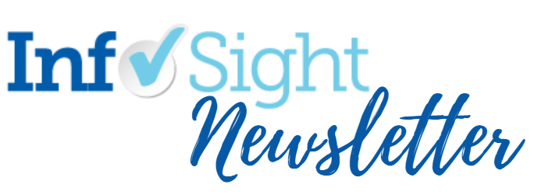

May 21, 2021 | Volume 15 | Issue 20

Highlights
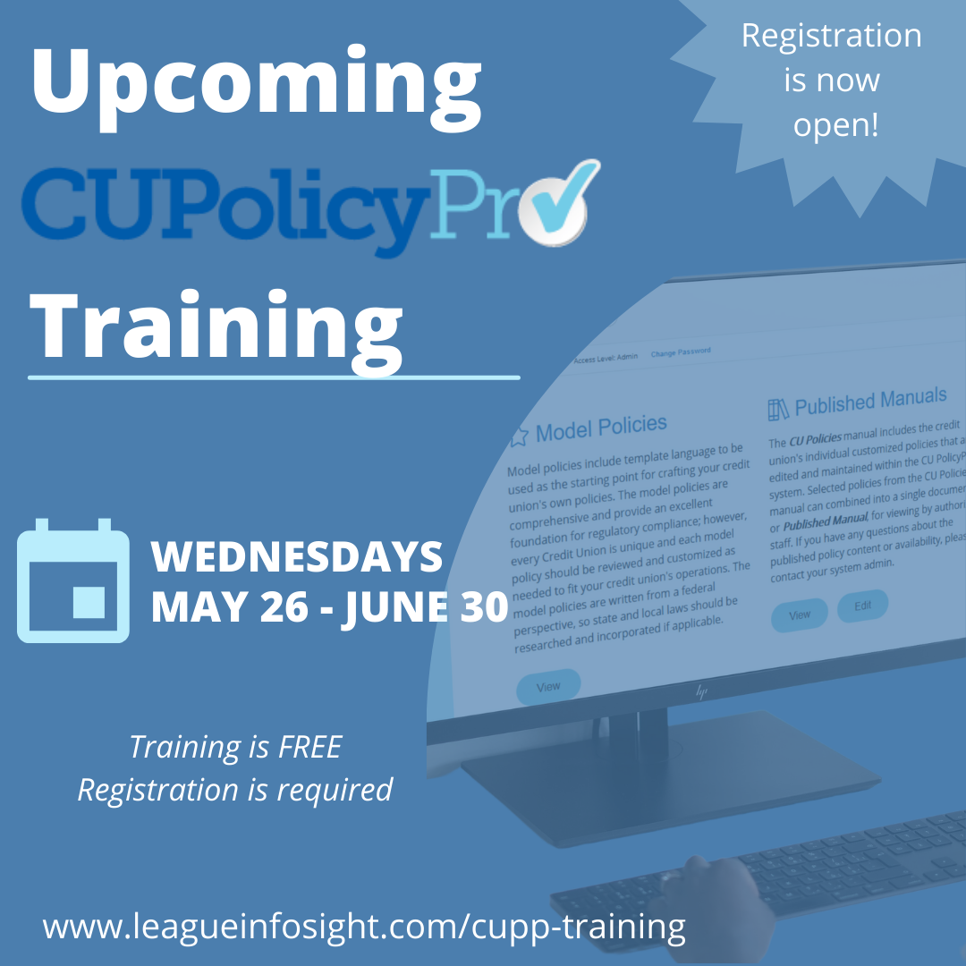

Register Now for CU PolicyPro Training!
We are pleased to offer a series of live training webinars to introduce you to (or reacquaint you with) CU PolicyPro. The training sessions are FREE, but registration is required. Click here to view the session listing and descriptions, and to register for each class. (Please note: there is no session on June 23, and all times are EDT.)

Compliance and Advocacy News & Highlights

Agencies Extend Comment Period for Info Gathering on Uses of AI

The Fed, CFPB, FDIC, NCUA, and OCC have announced they are extending the comment period on their request for information on financial institutions' use of artificial intelligence (AI) until July 1, 2021.

The agencies are seeking information from the public on how financial institutions use AI in their activities, including fraud prevention, personalization of customer services, credit underwriting, and other operations. More specifically, the RFI seeks comments to better understand the use of AI, including machine learning, by financial institutions; appropriate governance, risk management, and controls over AI; and challenges in developing, adopting, and managing AI.

Source: Regulatory Agencies

Fed Extends Reg O PPP Rule Again

The Federal Reserve Board has announced the third extension of a rule amending Regulation O to bolster the effectiveness of the Small Business Administration's (SBA) Paycheck Protection Program (PPP). Like the earlier extensions, this one will temporarily modify the Board's rules so that certain bank directors and shareholders can apply to their banks for PPP loans for their small businesses.

The rule extension, which is effective immediately, applies to PPP loans made from March 31 through June 30, 2021. The rule change will continue to apply if the PPP is extended, with the change ultimately sunsetting on March 31, 2022. Comments will be accepted for 45 days after publication in the Federal Register.

Source: FRB

NCUA Schedules Upcoming Webinars
Online registration for the May 26 webinar, “Critical Security Controls and Cyber Hygiene,” is open now. The webinar is scheduled to begin at 2 p.m. Eastern and will run for approximately 60 minutes. Participants will be able to log into the webinar and view it on their computers or mobile devices using the registration link and should allow pop-ups from this website to ensure easier access to the webinar. Participants can submit questions anytime during the presentation or in advance by emailing WebinarQuestions@ncua.gov. The email’s subject line should read, “Critical Security Controls.” Please email technical questions about accessing the webinar to audience.support@on24.com.
Online registration for this 60-minute May 27 webinar on Small-Dollar Loan Program, co-hosted by the National Credit Union Administration and the CDFI Fund, is open now. Participants will be able to log into the webinar and view it on their computers or mobile devices using the registration link. They should allow pop-ups from this website.
Staff from the NCUA and the CDFI Fund will describe the program and discuss eligibility and permissible uses of these funds. A question-and-answer session will follow the presentation. Credit unions should review the CDFI Fund’s Small-Dollar Loan Program webpage, including information about the application process and timeline.
Source: NCUA

NCUA Chairman’s Letter Re: LIBOR Transition
In a recent letter to Boards of Directors and Chief Executive Officers, NCUA Chairman Harper wrote:
“On March 5, 2021, the London Inter-bank Offered Rate (LIBOR) administrator announced it will stop publishing the one-week and two-month LIBOR settings immediately following the December 31, 2021, LIBOR publication.¹ The remaining LIBOR settings will cease immediately following the LIBOR publication on June 30, 2023. While the extension of the publication of certain LIBOR settings through June 30, 2023, is not an opportunity to continue using LIBOR, it will allow some legacy LIBOR contracts to mature naturally.
The NCUA encourages all federally insured credit unions to transition away from using the U.S. dollar LIBOR settings as soon as possible, but no later than December 31, 2021. Failure to prepare for LIBOR disruptions could undermine a federally insured credit union’s financial stability, and safety and soundness. As noted in the Federal Financial Institutions Examination Council’s (FFIEC) July 1, 2020, Joint Statement on Managing the LIBOR Transition, the LIBOR transition is a significant event that credit unions should manage carefully. The FFIEC statement recommends that new financial contracts use a reference rate other than LIBOR or have robust fallback language that includes a clearly defined alternative reference rate after LIBOR’s discontinuation.
The recent supervisory letter provides the supervision framework examiners will use to evaluate a credit union’s risk management processes and planning regarding the transition from LIBOR. The guidance applies to all federally insured credit unions, and I encourage all credit unions with LIBOR exposure to consult this information.
Please contact your NCUA Regional Office or state supervisory authority if you have questions about this important topic.”
Source: NCUA

Articles of Interest
- CFPB Adds Five New TRID FAQs re: Housing Assistance Loans
- Pandemic Issues Cause Drop in Consumer Satisfaction for Credit Unions, Banks
- Spotting Cryptocurrency Investment Scams

CUNA's Advocacy Resources:
- Happenings in Washington
WOCCU Advocacy Resources:
- Telegraph – the most recent newsletter on current advocacy issues
- Advocate Blog – International advocacy trends and issues

Compliance Calendar
- May 31st, 2021: Memorial Day - Federal Holiday
- June 30th, 2021: NACHA – Limitation on Warranty Claims
- June 30th, 2021: NACHA – Reversals
- July 5th, 2021: Independence Day - Federal Holiday (observed)
- September 6th, 2021: Labor Day - Federal Holiday

