May 14, 2021 | Volume 15 | Issue 19

InfoSight News
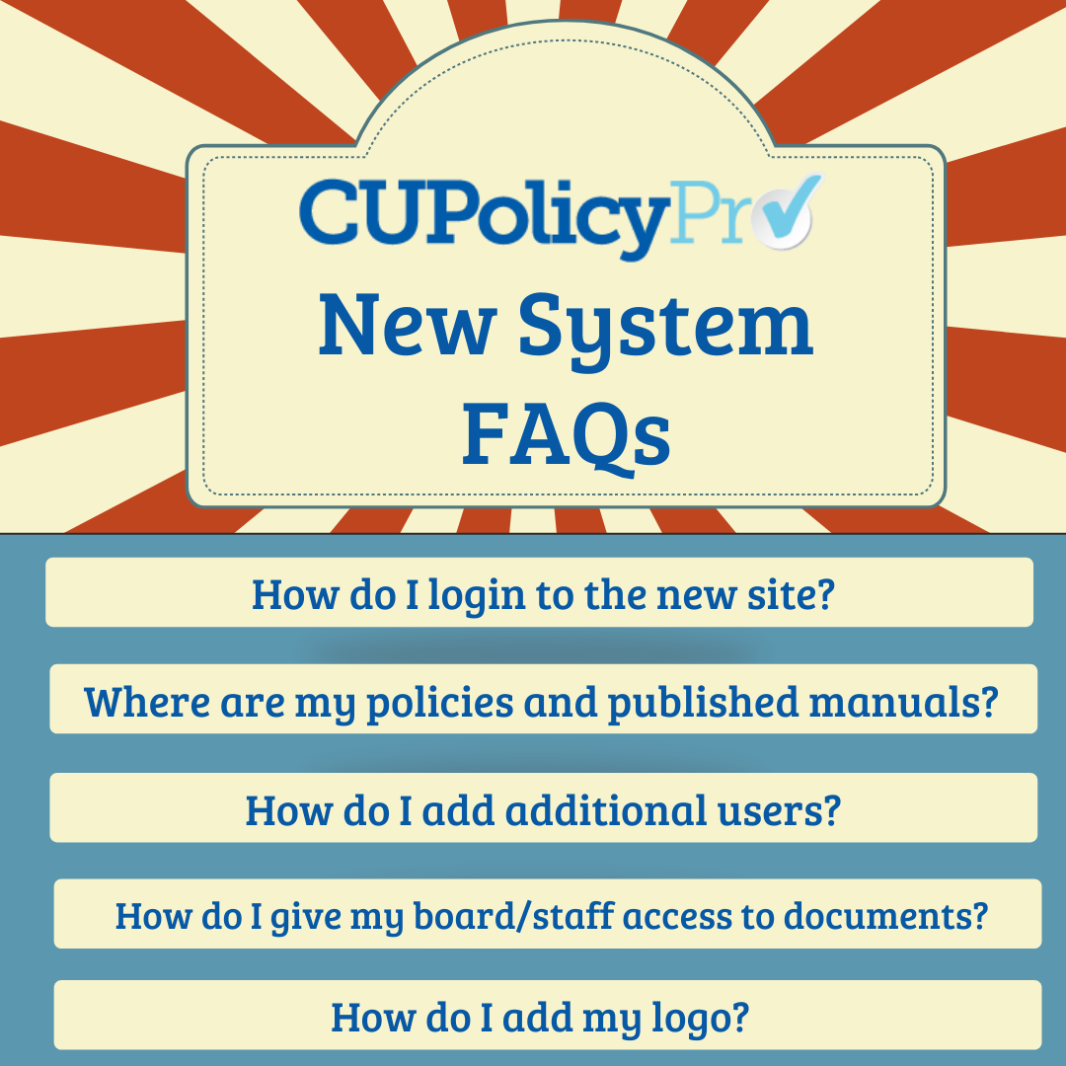

The new CU PolicyPro system launched at the end of last month, and we have received some great feedback about the new features and enhanced functionality! The launch did generate a larger than normal number of questions and requests for our support team in the past two weeks. We apologize if the response time was a bit slower than normal and appreciate everyone’s patience! We have assembled a list of the questions we received the most since the launch.

We welcome any additional questions, feedback and suggestions you may have. If you would like more information about CU PolicyPro’s new features, please visit the League InfoSight website!

Compliance and Advocacy News & Highlights

Federal Financial Regulators to Hold Webinar on Emergency Capital Investment Program
The National Credit Union Administration encourages credit unions interested in learning more about the Treasury Department’s Emergency Capital Investment Program to join an “Ask the Regulators” webinar hosted by NCUA and other federal financial regulators.

“This is an important opportunity for CDFI-certified and MDI-designated credit unions to expand access to affordable financial services and assist individuals and small businesses hit particularly hard by the pandemic,” NCUA Chairman Todd M. Harper said. “I strongly encourage all eligible credit unions to learn more about this program. It is the kind of effort that defines the credit union mission, and it can make a real difference to the people and communities they serve.”

The 75-minute webinar, “An Overview of the Emergency Capital Investment Program,” will take place on Monday, May 24, beginning at 3 p.m. Eastern.

Registration for the webinar is now open online. Participants may submit questions in advance by email at asktheregulators@stls.frb.org. Questions submitted by May 18 will receive priority.

Eligible credit unions interested in applying for the Emergency Capital Investment Program now have until July 6 to submit their applications.

Credit unions can review the Treasury Department’s ECIP information page in advance of the May 24 webinar to learn more about the program.

Source: NCUA

CFPB Issues Annual Report on Servicemember Affairs

The CFPB and its Office of Servicemember Affairs have issued their eighth annual report regarding their commitment to educating and empowering servicemembers, veterans, and military families, monitoring their complaints, and coordinating with other state and federal agencies to ensure their financial concerns are given the attention they deserve.

In 2020 the Bureau received over 40,000 complaints from servicemembers. These complaints are examined within the report in addition to narratives from servicemembers that discuss some of the emerging issues and continuing trends for military consumers in the financial marketplace.

Source: CFPB

CFPB and FTC Alert Landlords to Tenants' Pandemic Rights

Last week, CFPB Acting Director Dave Uejio and FTC Acting Chairwoman Rebecca Kelly Slaughter sent notification letters to the nation’s largest apartment landlords, which collectively own more than 2 million units. The letters reminded those landlords of federal protections in place to keep tenants in their homes and stop the spread of COVID-19. The Centers for Disease Control and Prevention (CDC) has extended until June 30 a temporary moratorium on evictions for non-payment of rent.

The letters also noted that the CFPB has issued an interim final rule, which took effect May 3, establishing new notice requirements under the Fair Debt Collection Practices Act (FDCPA). Landlords should ensure that any FDCPA-covered debt collectors (including attorneys) working on their behalf notify tenants of their rights under federal law (as required by the interim final rule).

Source: CFPB/FTC

Celebrating Older Americans Month
During May, the FTC and federal and state organizations nationwide will celebrate Older Americans Month, with “Communities of Strength” as its theme. The FTC works to protect older adults year-round, through law enforcement actions and the Pass It On fraud prevention campaign. Pass It On encourages people to share what they know to protect someone from a fraud, and to be a resource that others can turn to. The FTC has provided a series of blogs about scams affecting older adults. Share these blogs in your community. You can link, forward, print, or copy all FTC content freely. And if you’re on social media, share this graphic through your network.
Also during the month of May, and through June 15, the CFPB will spotlight tools and resources that can help older adults achieve and maintain financial well-being. The following resources for older adults, their families, and those who serve them during May and June on a variety of topics will be available:
- Financial caregiving – resources for those who help an older relative or friend manage their money.
- Housing decisions– help for those considering a reverse mortgage as well as current reverse mortgage borrowers.
- Planning for retirement– information on the factors that influence when to claim Social Security.
- Online and mobile banking tips– a few tips to help older adults get started since bank and credit union hours may be limited.
- Elder financial exploitation– resources to help older adults and their caregivers prevent, avoid, and report scams, fraud, and other forms of financial exploitation.
Source: FTC and CFPB
Articles of Interest
- Treasury Targets Hizballah Finance Official and Shadow Bankers in Lebanon
- HUD Charges Kansas Homeowners Association with Disability Discrimination
- 51% of Credit Union CEOs Are Women, Study Shows
- CFPB Finds Minorities at Higher Mortgage Default Risk

CUNA's Advocacy Resources:
- Happenings in Washington
WOCCU Advocacy Resources:
- Telegraph – the most recent newsletter on current advocacy issues
- Advocate Blog – International advocacy trends and issues

Compliance Calendar
- May 31st, 2021: Memorial Day - Federal Holiday
- June 30th, 2021: NACHA – Limitation on Warranty Claims
- June 30th, 2021: NACHA – Reversals
- July 5th, 2021: Independence Day - Federal Holiday (observed)
- September 6th, 2021: Labor Day - Federal Holiday

