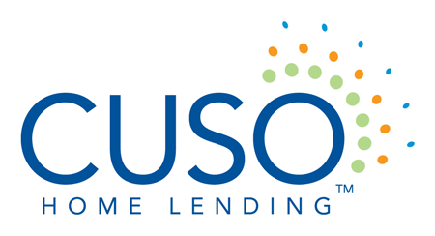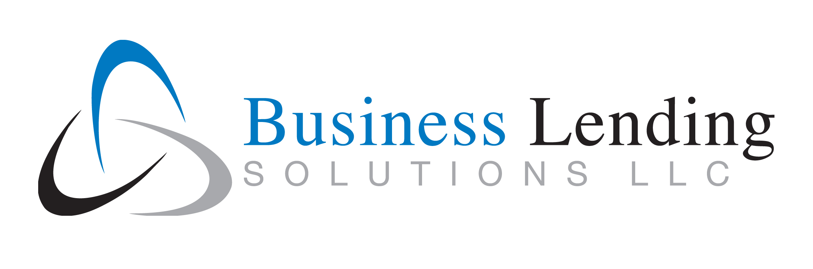

Residential and Business Lending Expo

Location: Italian Heritage Ctr., 40 Westland Avenue, Portland, ME
Date: March 18, 2020
Time: 8:45 AM – 3:30 PM (Social from 3:30 PM – 4:30 PM)
Agenda
7:45 – 8:45 Registration & Continental Breakfast –
8:45 – 9:45 Keynote Speaker – Dale Vermillion
10:00 – 10:45 Optimal Blue – Social Media Compliance
11:00 – 11:45 James Nadeau – Flood Changes in Maine
11:45 – 12:45 Buffet Lunch – Visit with Vendors
Residential Breakouts
1:00 – 1:45 “The Amazon Prime Effect” Understanding Changes in Borrower Buying Habits, Greg Korn/MGIC
1:45 – 2:30 Underwriting/Appraisal/Title Q & A Sandy Leavitt, Underwriter, Appraiser TBD, Title TBD
Commercial Breakouts
1:00 – 1:45 Commercial Lending Compliance – Mike Marino, M & M Consulting
1:45 – 2:30 Commercial Appraisals – Ken Charest, Appraisal Services
General Session
2:30 – 3:15 Realtor Panel Discussion - Lindsae Lasko & Jason Fish, Better Homes and Gardens, The Masiello Group; Aaron Chadbourne, Demetria’s Team – The Real Estate Group; Commercial Broker - TBD
3:15 – 4:15 Social Hour

