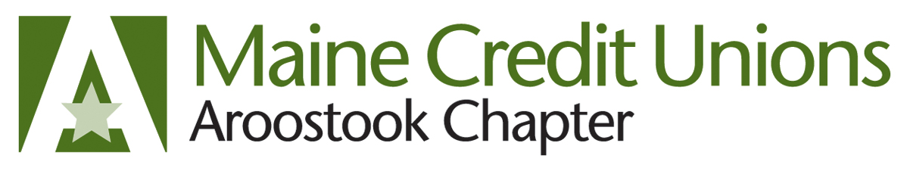
The Aroostook Chapter of Credit Unions is sponsoring its 9th Annual Snowmobile Run Fundraiser on Thursday, February 20, 2020 in conjunction with the Aroostook Chapter of Credit Union’s February 2020 Chapter Meeting hosted by NorState Federal Credit Union.
The Snowmobile Run is an annual event that the Chapter hosts to raise money for three very deserving organizations: Ending Hunger in Maine; Special Olympics; and CULAC (a legislative credit union action council).

Once again, we are asking for your generous support for this event. Sponsorships are divided into three levels as outlined below:

- Platinum - $250
  - Recognition of your organization in the Snowmobile Run Registration Packet, Chapter Meeting Program, all print or electronic correspondence (media, ads, etc…), as well as on Dinner Placemats.

- Gold - $200
  - Recognition of your organization in the Snowmobile Run Registration Packet, Chapter Meeting Program and on the Dinner Placemats

- Silver - $100
  - Recognition of your organization in the Snowmobile Run Registration Packet and Chapter Meeting Program

As an extra added incentive, your donation will be inclusive as a sponsor for the Aroostook Chapter of Credit Unions ATV Outing planned for June. Invitations and more details to follow for that outing in the spring!

We appreciate any donation that your organization deems fit and again, all funds raised from the event will benefit Maine charities.

To Sponsor this event, please make your check payable to NorState Federal Credit Union and mail to:
Dennis Voter, NorState F.C.U.
c/o Aroostook Chapter of C.U.
78 Fox Street, Madawaska, ME 04756

Con’t…
In addition, we welcome you or any of your employees to join us for the Snowmobile Ride. It will begin and end at Lakeview Restaurant in St. Agatha at a cost of $20 per registrant for just the ride or $45 for the ride and dinner. All participants who finish the snowmobile run will be eligible for prizes drawn at the dinner that evening. The event is open to all credit union employees, volunteers and their invited guests as well as credit union vendors, sales affiliates, and event sponsors and to friends and family. There is plenty of truck and trailer parking at the venue.
The itinerary for the day is as follows:
7:30am- Breakfast (sponsored by Insurance Trust)
7:30 to 8:30am – Registration for those who haven’t pre-registered
8:30am – Rider’s Meeting & Instructions inside, Group Photo outside
8:30am – Snowmobile Ride
4:30pm – Chapter Manager’s Meeting for CU officers only
5:00 pm – Social for riders (open to sponsorship) 5:30 Social start for CU staff
6:00pm – Dinner (If you wish to stay for Dinner, please RSVP by Feb.5th so that we can ensure that the Restaurant can accommodate you)
7:00pm – Guest Speaker/Presentation
8:00pm – Prize Drawings for Riders (open to sponsorship)
Additional correspondence is available for registrants such as: availability of snowmobile rentals, local lodging, or if in need of information, please contact Dennis Voter at 800-804-7555 ext: 118 or email: dvoter@norstatefcu.org
You may register to ride in this year’s event by emailing John Dixon, jdixon@norstatefcu.org for a registration form.

We look forward to hearing from you!

Denise Duperré

Denise Duperré, Aroostook Chapter Chairperson

