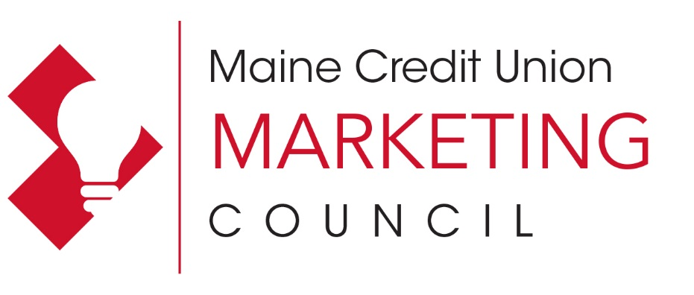

Attention: Marketing Professionals

Maine Credit Union Marketing Council 2020 Dues Announcement

The Maine Credit Union Marketing Council is a credit union network for marketers and other staff at credit unions responsible for the marketing and promotion of credit union products and services.

Benefits to Maine Credit Unions:
- Provides exposure to the latest marketing concepts and tools
- Supports the credit union movement with networking and educational opportunities
- Council members hear industry experts without having to pay national conference fees by pooling dues

Background:
The Maine Credit Union Marketing Council was formed in October 1996 as a networking and educational forum for Maine's Credit Unions. Each credit union pays annual dues of $185 to cover speaker fees, and the credit union may send as many staff members as it would like to the workshops. An additional per-person workshop fee is charged to cover the event location and meal.

The Council has drawn marketers as well as CEOs, operational staff and MSRs to hear programs from national CUES and CUNA conference speakers, panelists from the region, and experts from specific industries. While vendors may make presentations, they cannot be sales driven. The educational focus has been the success of the workshops, along with the networking opportunities.

Who is eligible to join?
Maine Credit Union League members and affiliates.

Contact:
For more information, please contact Jen Burke, League Public Affairs & Communications Manager at jburke@mainecul.org, or 800.442.6715, ext. 295.
2020 Annual Dues Form

We hope you will join your colleagues for networking and idea exchanges all while learning about the latest marketing tips and trends. Sign up today!

Credit Union _________________________________________________________

Primary Contact:
____________________________________Phone_____________________Ext____

Email address__________________________________________________________

Please include below other staff members who should receive Marketing Council workshop communications and emails:

__________________________________ Email address_________________________

__________________________________ Email address_________________________

Payment: Circle one option below:

- Debit our Tricorp account for the dues fee of $185. A completed settlement authorization form is already on file at the League or is included with this form.

- A check is enclosed payable to the Maine CU Marketing Council.

Please email this completed form to jburke@mainecul.org by January 31, 2020, or mail forms to: Maine Credit Union League, Attn: Jen Burke, PO Box 1236, Portland, ME 04104

We will be holding a workshop in the spring of 2020. Please list below specific topics you would be interested in learning about at a future Marketing Council event and a preferred location for our next workshop.
________________________________________________________________________________________________________________________________________________________________________________________________________________________

