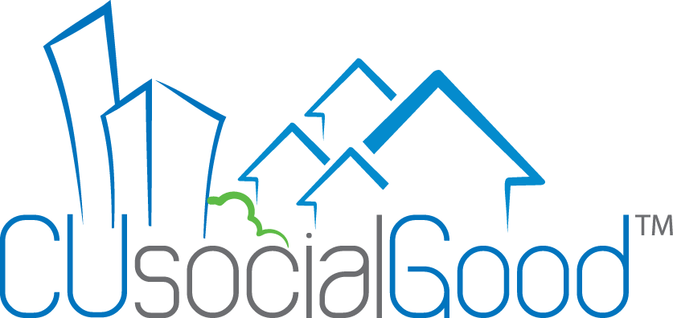
FAQs – CU Social Good
Q: Why should I join CU Social Good?
A: CU Social Good is the ONLY platform that is dedicated solely to the sharing of the good deeds that credit unions do each and every day. If we don’t tell our story, who will?
Q: Why should I create an account to share my stories, why not just email to CU Social Good in my general press release?
A: There are distinct benefits to joining CU Social Good, creating a profile for your credit union, and submitting your stories via the website. Once you have established your profile and it is approved by admin, your credit union will appear on our social impact map. Going forward, each story you submit will begin to aggregate under your credit union name, along with the dollar amounts and hours of volunteer work. Through inputting this data, you can generate individualized reports that show how much your credit union is doing. In addition, each credit union has the option to select which congressional district they are in, which can help create a stronger report when advocating for credit unions and visiting with legislators . And it’s all FREE for credit unions!
Q: What email address should I use to create a profile?
A: Because people often change jobs or titles, we recommend having a general marketing email address that will transfer to the job description as opposed to an individual’s email address, but you can use any email you want.
Q: Why do I need to enter my credit union’s congressional district in the profile?
A: CUSG is more than just a platform to showcase the good deeds that credit unions do; it is a powerful advocacy tool that can demonstrate to our legislators the real impact that credit unions have in the areas that they represent. The reports that can be generated from CU Social Good can be customized to show detail from any specific congressional district.
Q: I am trying to create a profile but it’s not accepting my password.
A: Your CU Social Good password must be a minimum of 6 characters, including 2 letters and 2 non-letters.
Q: What if I forget my password or my user name?
A: The user name will be the email address that was used to set up the profile. If you forget the password, your user name, or need to change either, you can easily contact us by emailing sharestories@cusocialgood.com or call 701.250.3966.
Q: Do I have to send a picture with my story?
A: We love pictures, and they often have as much or even more impact than the actual story! But don’t worry, if you don’t have a photo you want to share, you can use your credit union’s logo.
Q: Why do I need to enter the dollar amount of a contribution or the hours volunteered if that info is already in the story?
A: In order for the data from your credit union’s contributions to be aggregated under your credit union’s name, your state, and your congressional district, you must enter the figures into the appropriate field. The more data we can capture, the more accurately we can demonstrate, together, the powerful impact that credit unions make locally and nationally.
Q: I’ve submitted a story, why can’t I see it on the website now?
A: Once your story is submitted, it still has to be approved by admin before it appears on the website. Please allow time for processing. Typically we manage to get every story posted on a daily basis, but occasionally there are delays.
Q: How does this benefit my credit union, really?
A: Telling the story about the real impact credit unions make in their communities, in their states, in the country, and indeed, in the world, benefits not only your credit union – but the entire industry. CU Social Good is a way to collectively tell the stories, share ideas, and take advantage of free marketing opportunities as the stories are shared across social media.

